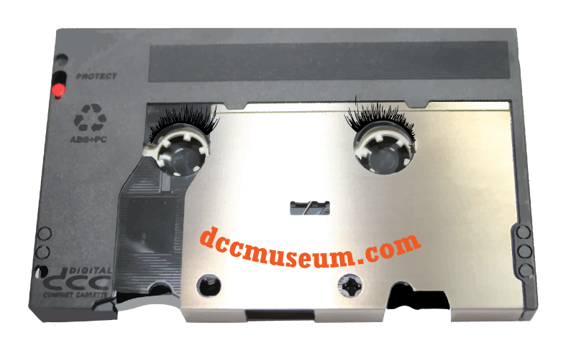

The DCC Museum Presents……..Jeremy Heiden Intro-Outro

The DCC Museum Presents……..Jeremy Heiden Intro-Outro

The DCC Museum Presents……..Jeremy Heiden Intro-Outro

