ROLLING STONES GREATEST HITS & FAZED COOKIES (CD 1997)
Audio DCC Tray Liner (front template)
Drawing 1a: Side label for ALL –USER–DCCs (8,40cm by 0,65cm)
ROLLING STONES GREATEST HITS & FAZED COOKIES (CD 1997)
Drawing 1b: Side label for ALL –SUPER–USER–DCCs (8,40cm by 0,65cm)

Rolling Stones
ROLLLLIING STONES
GREATEST HITS
&
FAZED COOKIES

CD 1997
27 Tunes
ROLLING STONES
GREATEST HITS & FAZED COOKIES
(CD 1997)

GREATEST HITS
&
FAZED COOKIES

Drawing 2: Top label for PHILIPS DCC (5,40cm by 2,90cm)

CD 1997
27 Tunes
Drawing 3: Top label for BASF-2ndGen DCCs (4,00cm by 2,60cm)

ROLLING STONES
GREATEST HITS
&
FAZED COOKIES
CD 1997
27 Tunes

Drawing 2: Top label for PHILIPS DCC (5,40cm by 2,90cm)
Drawing 3: Top label for BASF-2ndGen
DCCs (4,00cm by 2,60cm)
ROLLING STONES
GREATEST HITS
&
FAZED COOKIES

CD 1997
27 Tunes

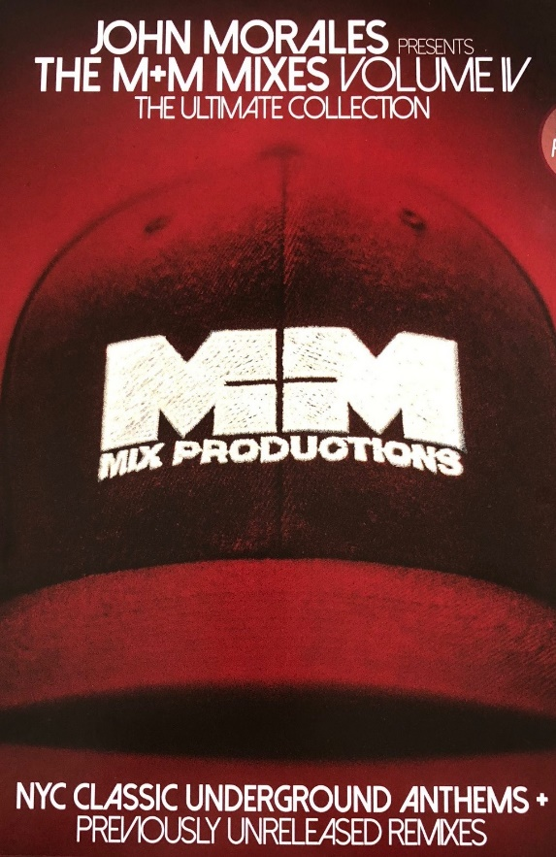
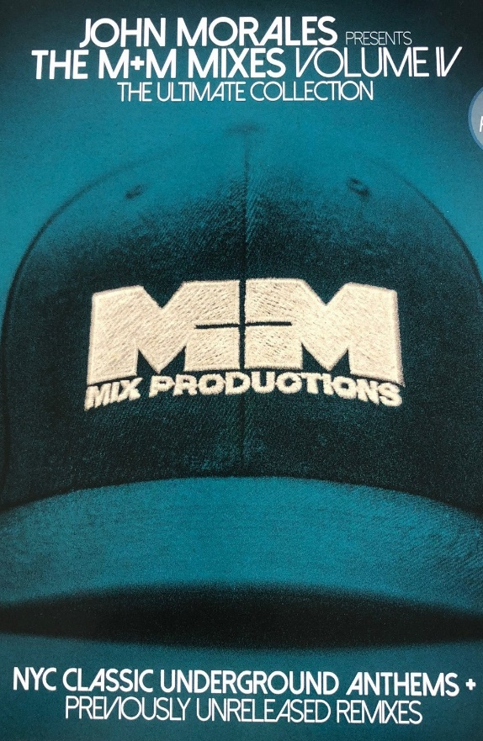

Template Name:
Template Size: 8.5” x 11”

John Morales – The M+M Mixes Vol 4 Tape 1
John Morales – The M+M Mixes Vol 4 Tape 2

John Morales Tape 2:

Barry White – Let The Music Play
MFSB – Love Is The Message
Mannix – Standing Right Here
Teena Marie - Lovergirl

John Morales Tape 1:

Barry White – I’M Gonna Love You Just
A Little Bit More Baby
Lenny Williams – You Got Me Running
Dan Hartman – Vertigo/ Relight My Fire
Level 42 – Mind On You

