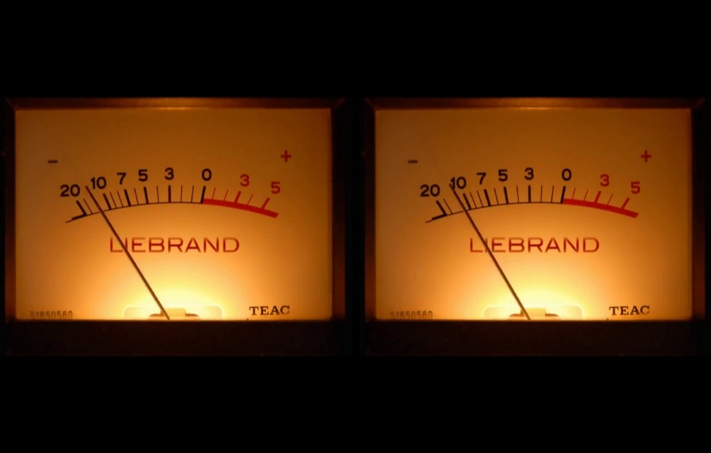

**Ben Liebrand – In the Mix 14-4-1984**

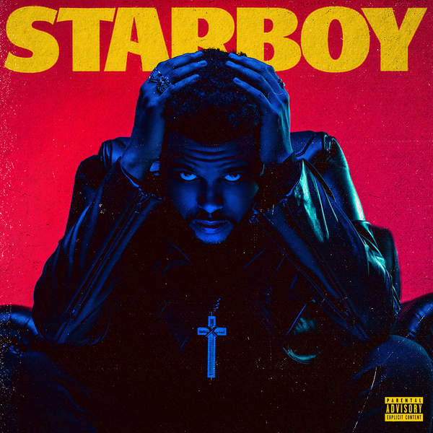

Motown Hit Tape

The Weeknd:

Starboy

Party Monster

False Alarm

Reminder

Rockin

Secrets

True Colors

Stargirl Interlude (Feat Lana De)

Sidewalks (Feat. Kendrick Lamar)

Six Feet Under

Love To Lay

A Lonely Night

Attention

Ordinary Life

Nothing Without You

All I Know (Feat. Future)

Die For You

I Feel It (Feat. Daft Punk)

Starboy Kygo Remix (Feat. Daft Punk)